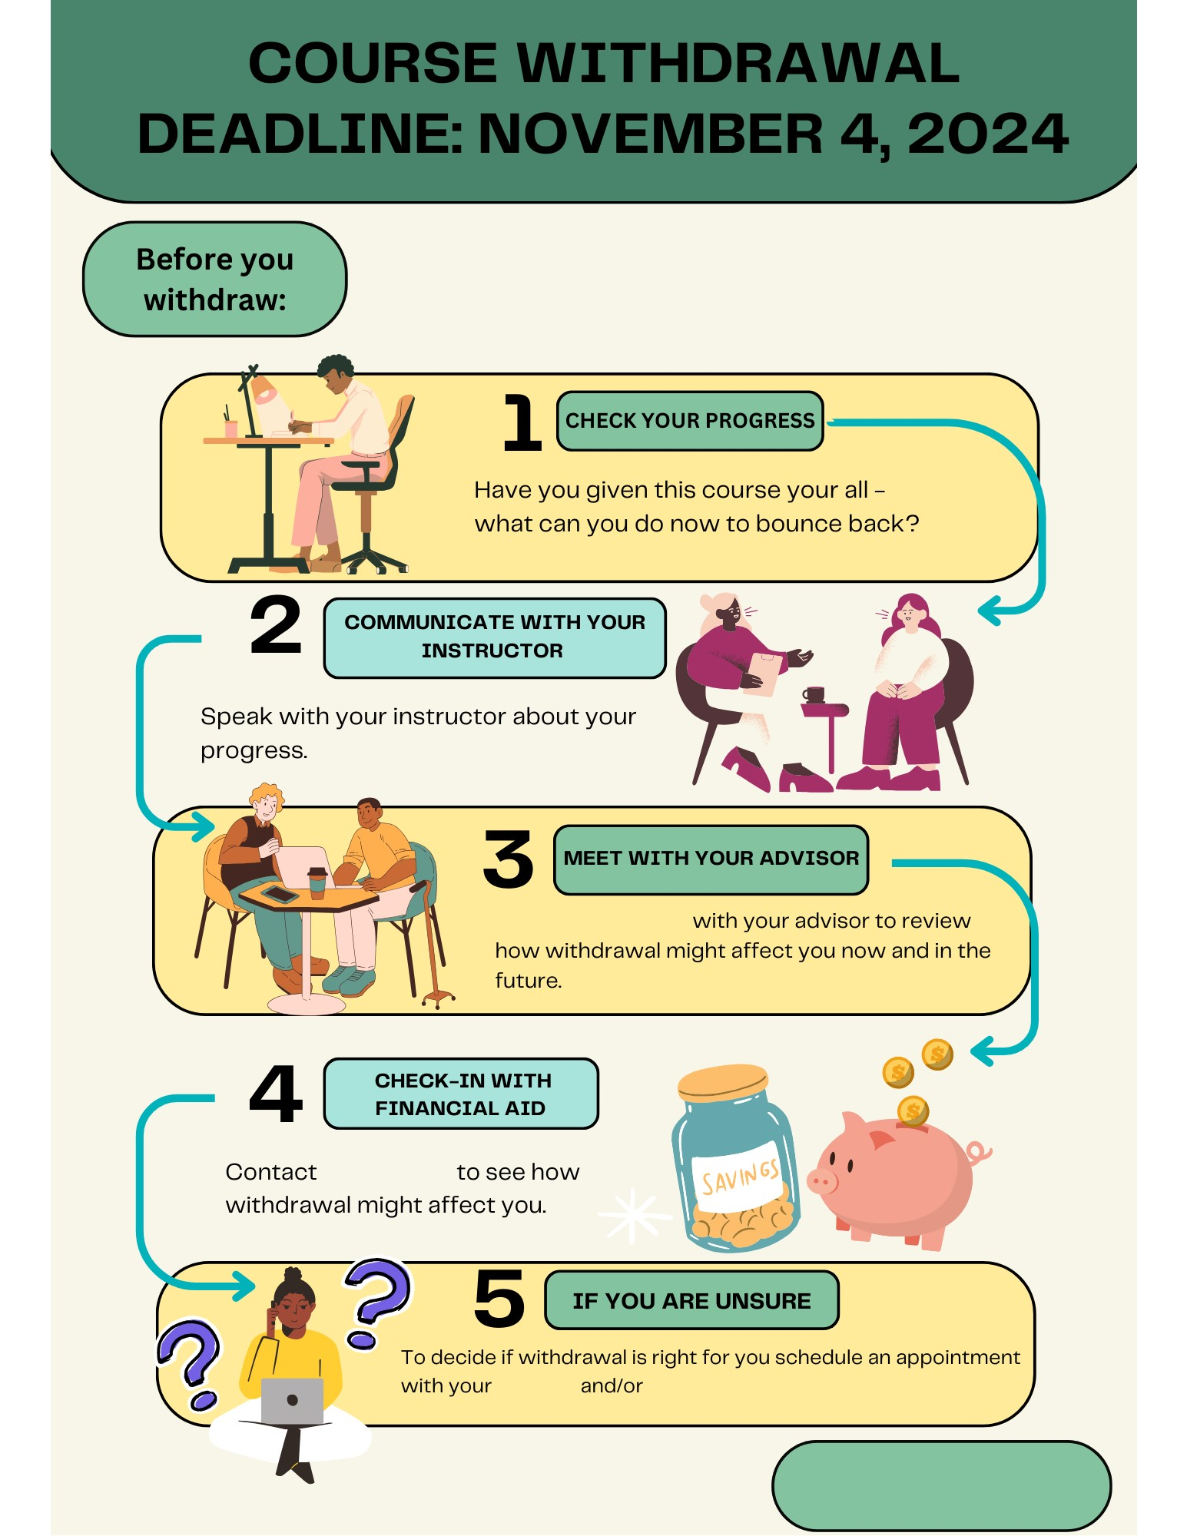

[**HOW TO WITHDRAW**](https://wayne.edu/registrar/withdrawals)

[academic persistence specialist](https://stars.wayne.edu/student/advisor/hp4763/)

[advisor](https://wayne.edu/financial-aid)

[Set up an appointment](https://wayne.edu/advising)

[financial aid](https://wayne.edu/financial-aid)